1. **Which are the top three variables in your model which contribute most towards the probability of a lead getting converted?**

The top three variables (in decreasing order) in my model which contribute most towards the probability of a lead getting converted are:

* Lead Source_Welingak Website
* Lead Origin_Lead Add Form
* What is your current occupation_Working Professional

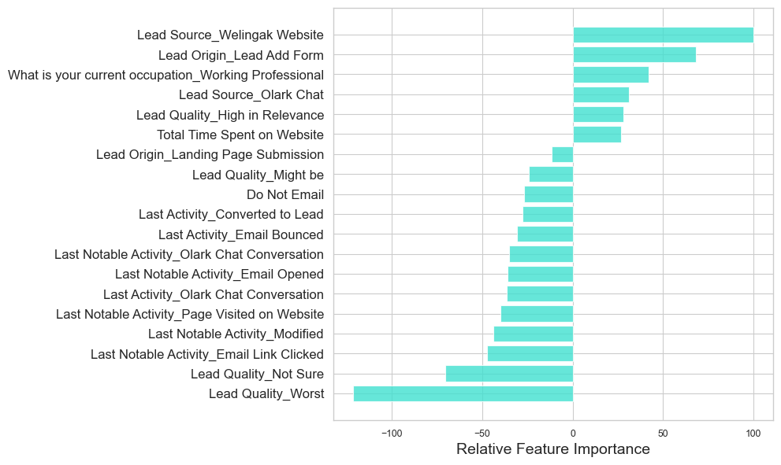

1. **What are the top 3 categorical/dummy variables in the model which should be focused the most on in order to increase the probability of lead conversion?**

The top 3 categorical/dummy variables in the model which should be focused the most on in order to increase the probability of lead conversion

* Lead Source_Welingak Website
* Lead Origin_Lead Add Form
* What is your current occupation_Working Professional

These have the highest positive coefficients as per our model

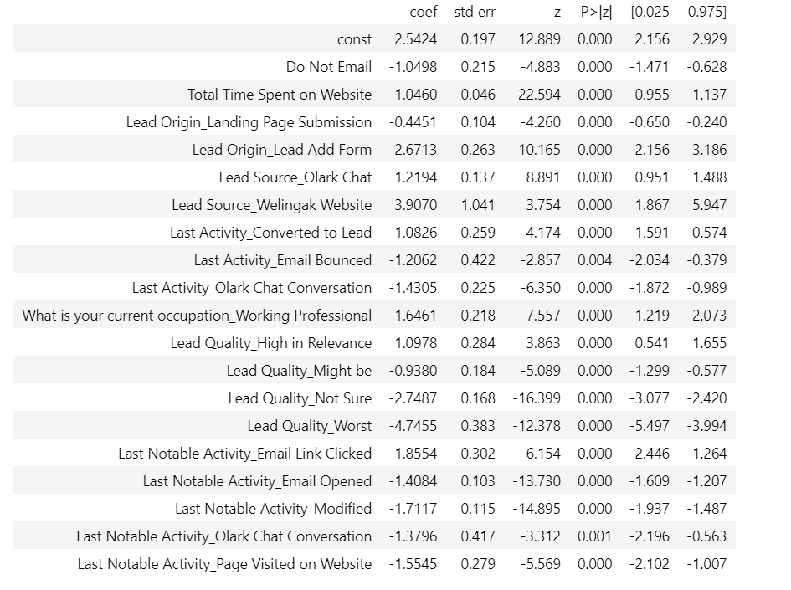

1. **X Education has a period of 2 months every year during which they hire some interns. The sales team, in particular, has around 10 interns allotted to them. So during this phase, they wish to make the lead conversion more aggressive. So they want almost all of the potential leads (i.e. the customers who have been predicted as 1 by the model) to be converted and hence, want to make phone calls to as much of such people as possible. Suggest a good strategy they should employ at this stage.**

Sensitivity, in the context of our model, refers to the proportion of actual conversions that are correctly predicted out of the total number of actual conversions. Conversely, specificity represents the proportion of actual non-conversions that are correctly predicted out of the total number of actual non-conversions.

By adjusting the conversion probability cutoff threshold value, we can achieve different values for sensitivity and specificity in the same model. As one of these measures increases, the other tends to decrease, and vice versa.

The graph below illustrates the relationship between sensitivity and specificity ratings in our model as the threshold value changes:

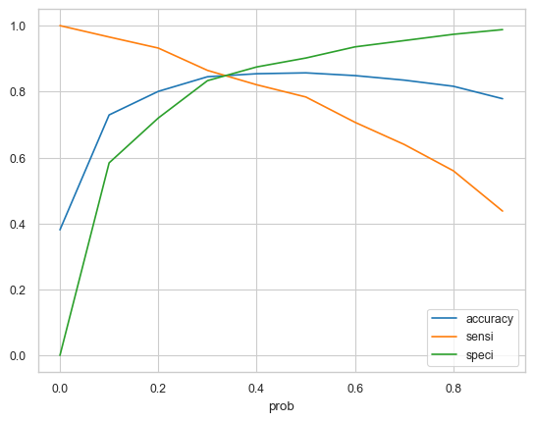

A high sensitivity implies that our model will accurately identify a significant majority of leads who are likely to convert. Considering that X Education has sufficient manpower during these two months and aims to increase lead conversion aggressively, it would be advantageous to choose a lower threshold value for the conversion probability. This decision will result in a high sensitivity rating, ensuring that almost all leads who are likely to convert are correctly identified. By doing so, agents can proactively make phone calls to a larger pool of potential leads, maximizing the chances of conversion.

1. **Similarly, at times, the company reaches its target for a quarter before the deadline. During this time, the company wants the sales team to focus on some new work as well. So during this time, the company’s aim is to not make phone calls unless it’s extremely necessary, i.e. they want to minimize the rate of useless phone calls. Suggest a strategy they should employ at this stage.**

Continuing from the previous question and considering the same context, a high specificity indicates that our model will accurately identify the majority of leads who are not likely to convert. However, achieving high specificity comes at the expense of potentially misclassifying some conversion cases as non-conversions.

Since X Education has already achieved its quarterly targets and aims to minimize unnecessary phone calls, it is preferable to choose a higher threshold value for the conversion probability. By doing so, we can maximize the specificity rating, ensuring that almost all leads who are on the borderline of converting or not are not selected. This approach minimizes the rate of useless phone calls, allowing agents to focus on new tasks instead.